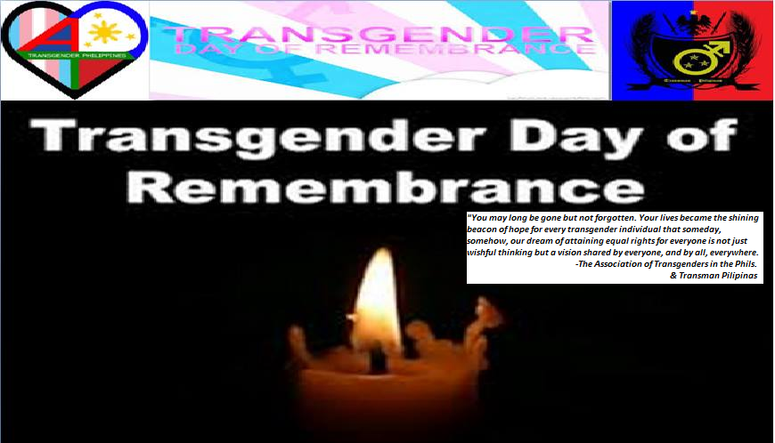
COMMUNIQUE
“CALL FOR ACTION”
Joint Statement of the Association of Transgenders in the Philippines & Transman Pilipinas
on the Occasion of the Transgender Day of Remembrance
November 20th, 2013

The men and women of the Association of Transgenders in the Philippines and Transman Pilipinas express solidarity with the rest of the transgender community in celebrating this year’s “Transgender Day of Remembrance (TDOR)”. ATP and TMP stand committed to fighting all forms of gender-based violence and discrimination. As men and women of conscience, we reject transphobia and hate crimes.
Over the years, much attention has focused on tackling gender-based violence and hate crimes. More recently, we have become increasingly concerned and alarmed with the prevalence of hate crimes and the unabated incidents of killings of individuals because of their gender identity and sexual orientation. Overtime, transgender individuals have become more vulnerable than ever to a wide range of human rights atrocities and similar violations including rape and at times, even arbitrary detention.
The sorry state of transgender individuals all over the world can also be credited to a series of state-sanctioned oppression and repression. The absence of institutionalized mechanisms to protect transgender people exposes them to higher risks of arrests, imprisonment and worst, death or execution. This is particularly true for those who are engaged in sex work. The issue of trans health husbands the equally important issue of trans empowerment.
The Association of Transgenders in the Philippines and its allies would like to speak out—calling for a more vigorous worldwide response against transphobia. We call to reinforce and strengthen measures to protect transgender individuals from any forms of violence. The eventual passage of the Anti-Discrimination Bill pending in Philippine Congress would pave the way for a more formidable approach aimed at combating any infractions of transgender rights and LGBT rights. We call for the introduction of the Gender-recognition legislation in Congress that would grant corresponding protection and rights to transgender people.
Furthermore, we believe that transphobia perpetuates stigma and contributes to a culture of intolerance and hatred. We therefore, urge the Philippine government, and all other states, to take steps to help eliminate transphobia and gender-based violence wherever it may be. We urge further, that all governments must take affirmative action to ensuring that social and legal frameworks are established to foster respect for transgender rights as part of human rights. In the words of US Vice-President Joe Biden : “ Transgender discrimination is the civil rights issue of our times”.
Today, as we honor the memory of all transgender people who have been killed and made victims of gender-based violence and hate crimes, we pause to REFLECT, to REMEMBER and to CONTEMPLATE. The fight for equality continues...
This is our shared goal; this is our pledge.

Association of Transgenders in the Philippines (SGD)
Transman Pilipinas (SGD)

